"[Testing the Data Warehouse Praticum: Assuring Data Content, Data Structures and Quality](http://books.google.com/books/about/Testing_the_Data_Warehouse_Practicum.html?id=B6N84VHVCdUC)"

**Some of the main challenges of data warehouse testing are:**

**http://www.querysurge.com/Site/web/images/buttons/data-completeness-icon-48.png**Data Completeness

Verifying that all data has been loaded from the sources to the target Data Warehouse.

**http://www.querysurge.com/Site/web/images/buttons/data-transformation-icon-48.png**Data Transformation

Ensuring that all data has been transformed correctly during the extract-transform-load (ETL) process.

**http://www.querysurge.com/Site/web/images/buttons/data-quality-icon-48.png**Data Quality

Ensuring that the ETL process correctly rejects, substitutes default values, corrects or ignores and reports invalid data.

**http://www.querysurge.com/Site/web/images/buttons/regression-testing-icon-48.png**Regression Testing

Ensuring existing functionality remains intact each time a new release of code is completed.

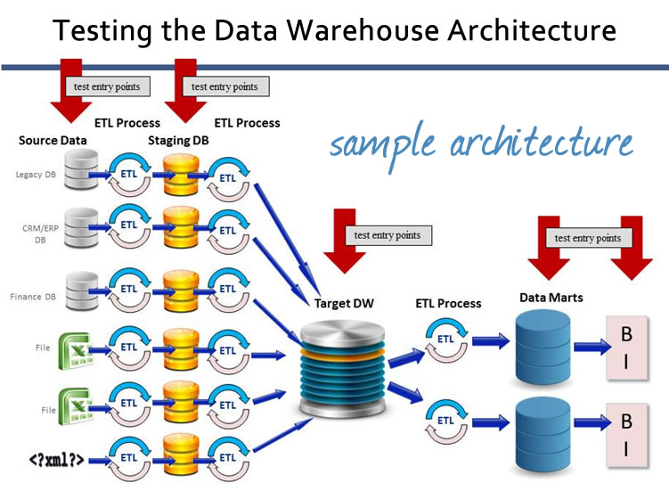

**QuerySurge**is the leading solution for automating the testing of Data Warehouses and the ETL testing process.